EXPERRIMENT-2

AIM:

To find the current using Mesh Analysis, Nodal Analysis, Superposition Theorem.

PROCEDURE:

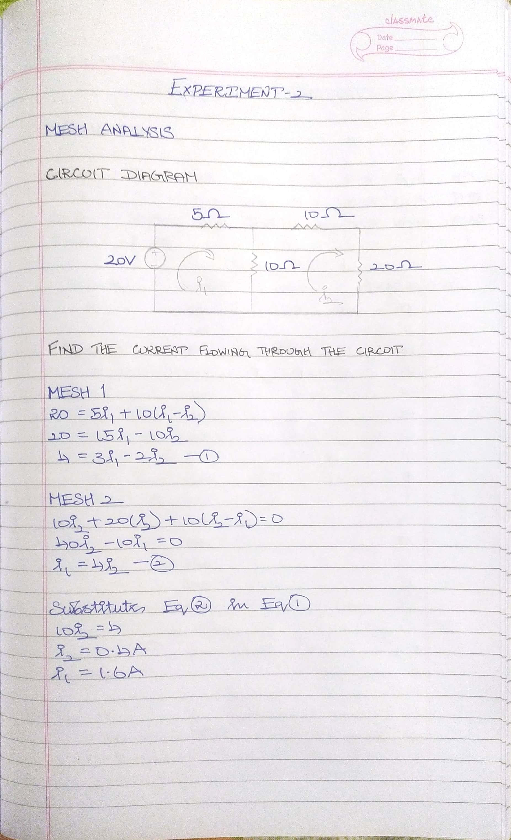

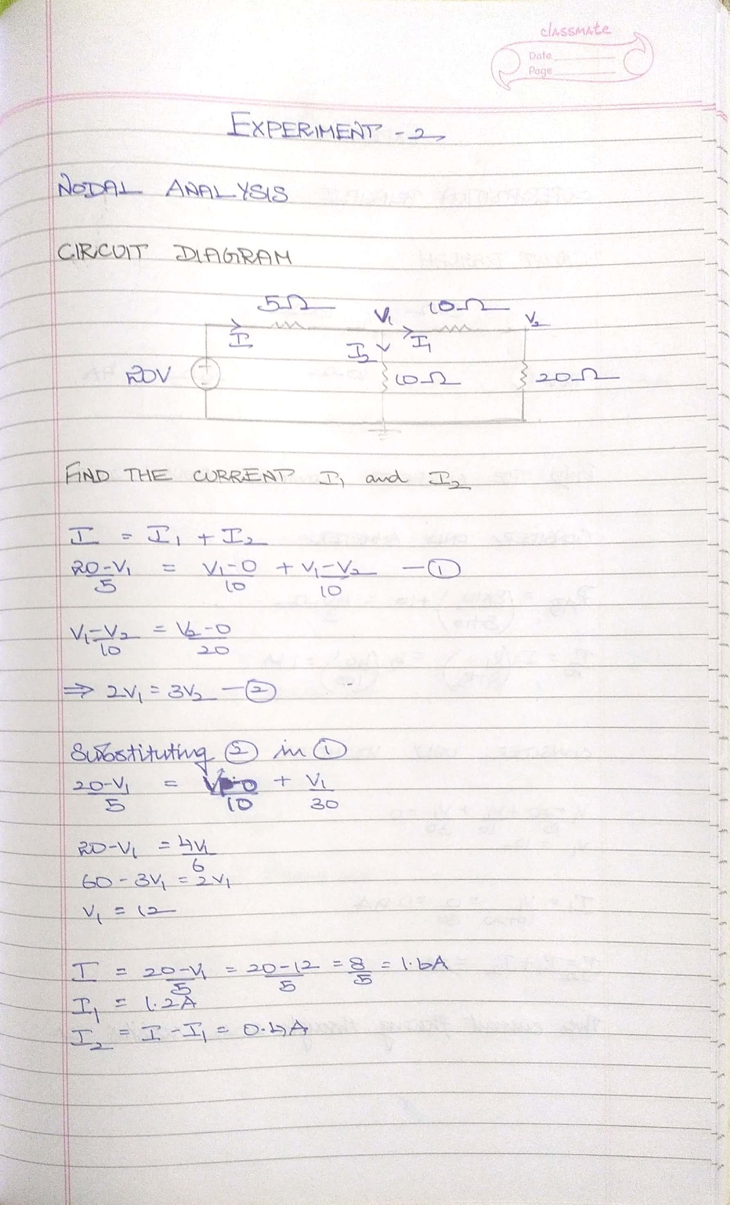

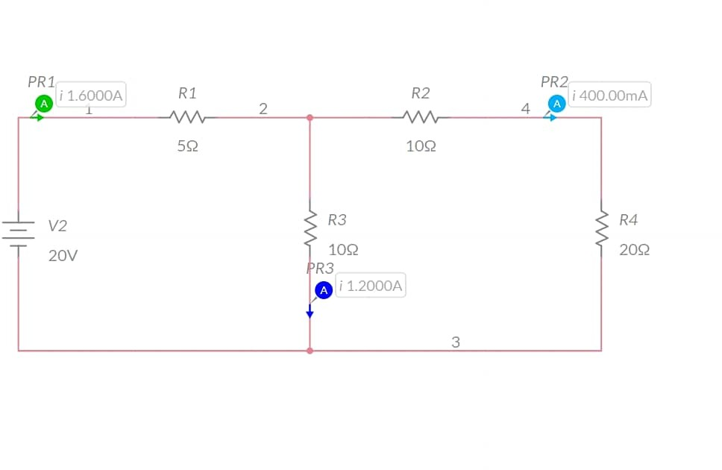MULTISIM:

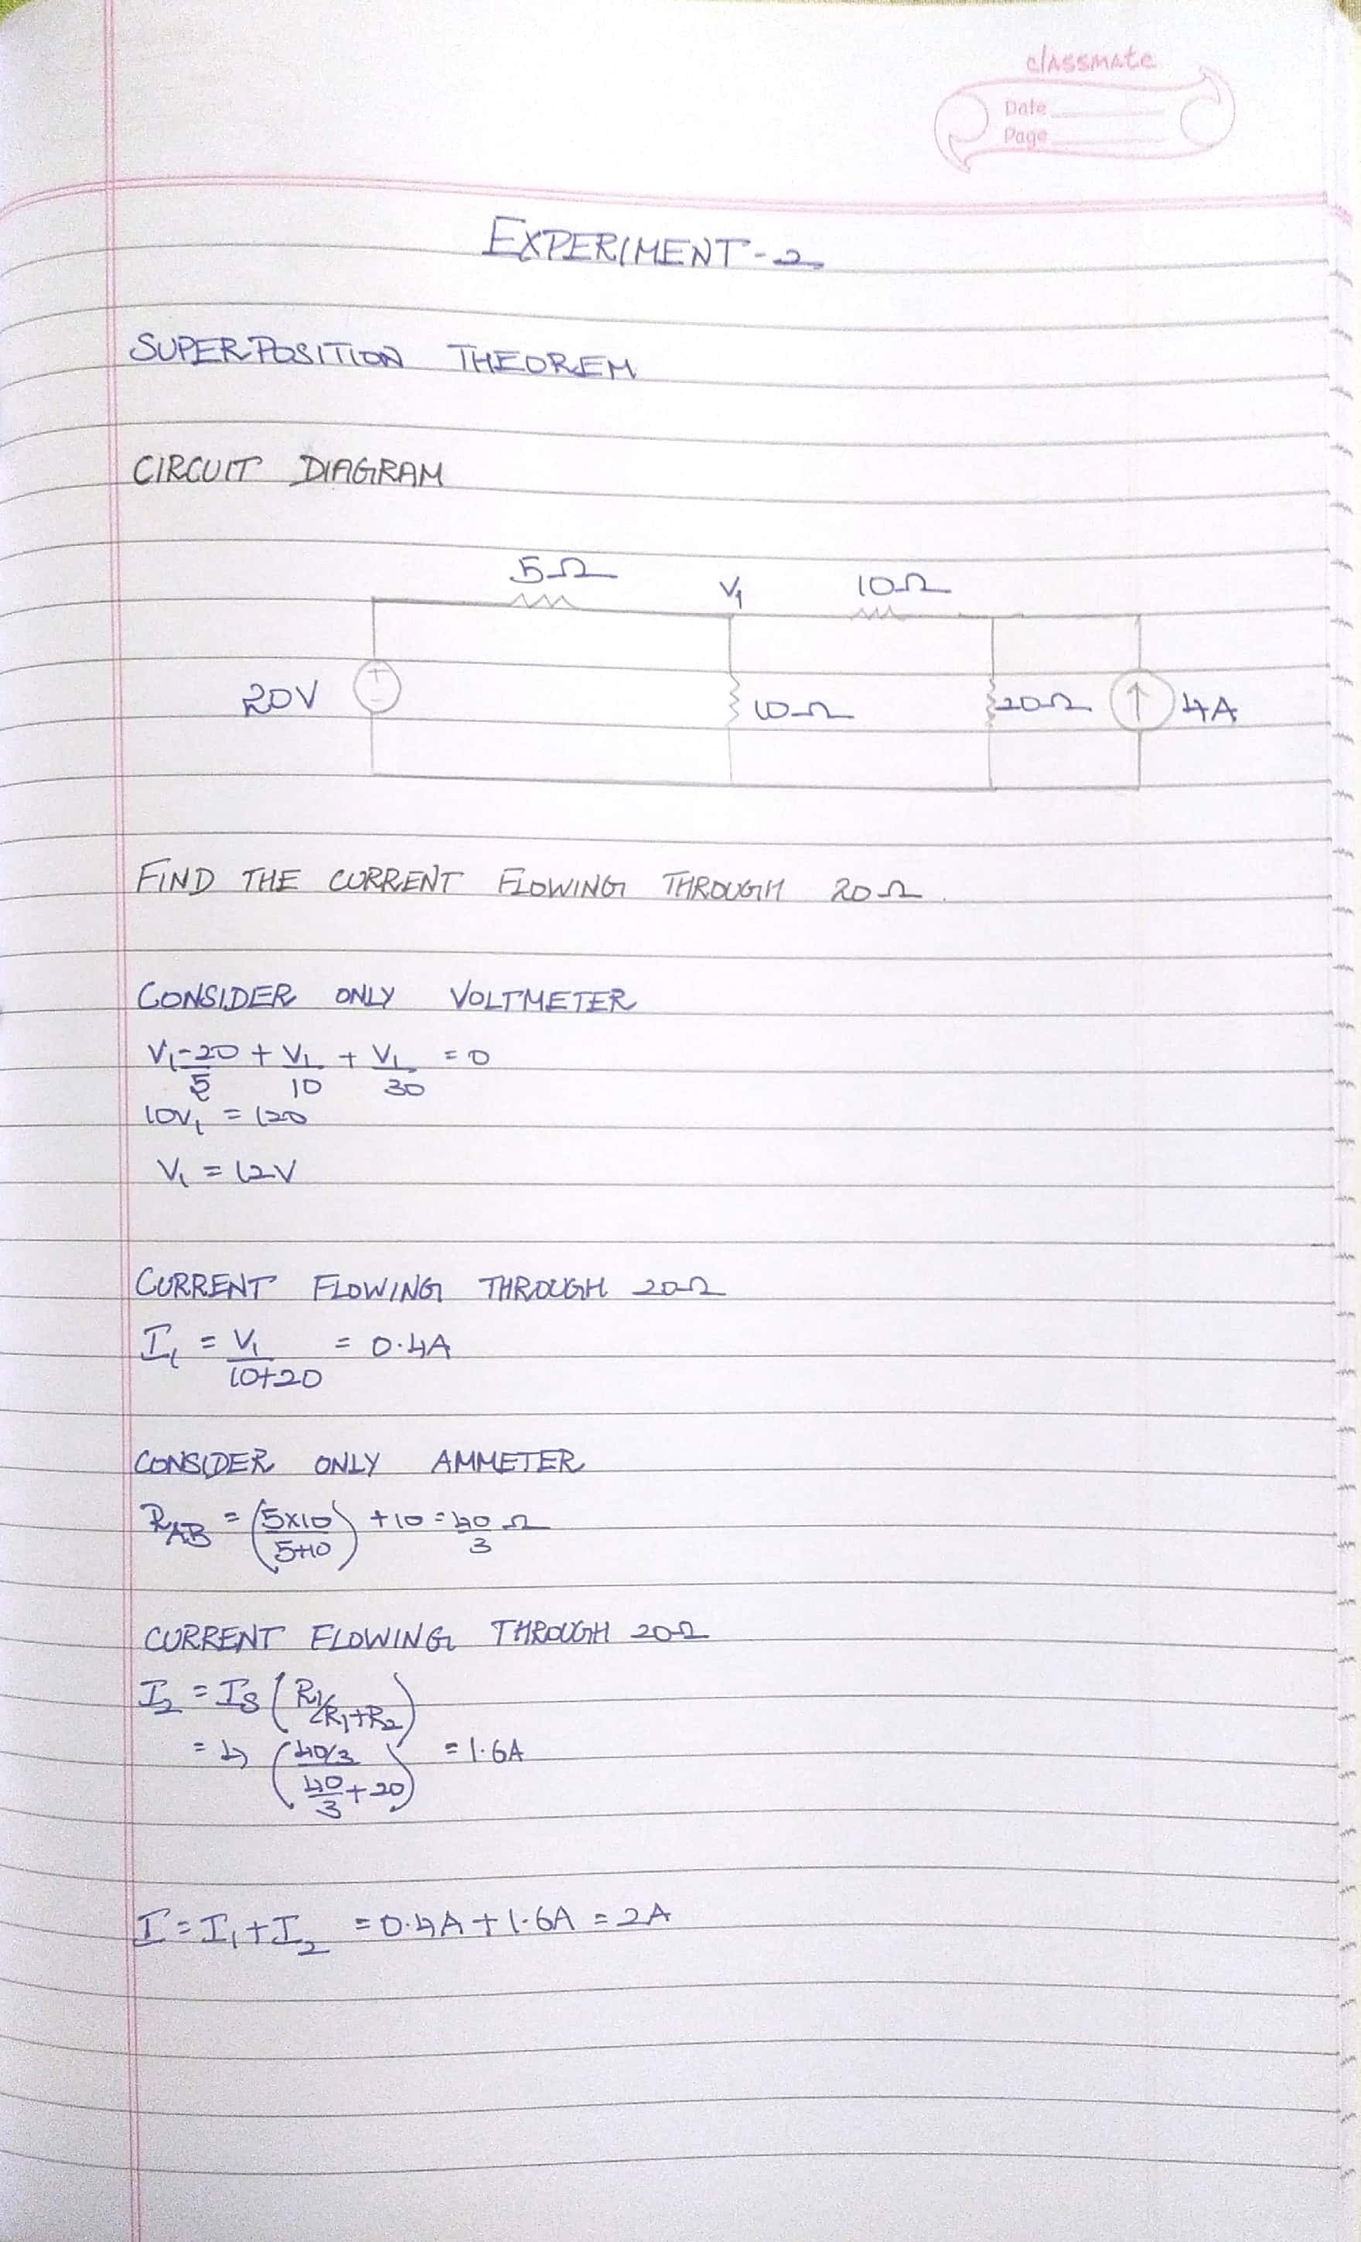

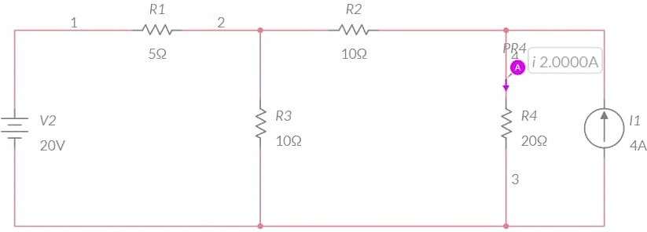MULTISIM:

CONCLUSION:

The value of current we got from MULTISIM is same as the value what we got theoretically.

NAME: G R NITIN

ROLL NO: CB.EN.U4CYS21017